Stefano Ospitali
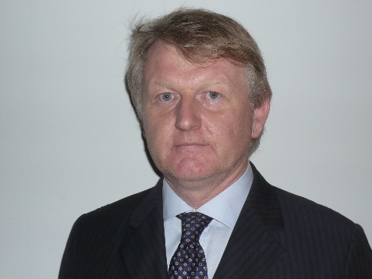
My profile:
STEFANO OSPITALI – Chief Executive Officer Cesare Ragazzi Laboratories – Italy.
Graduated in 1989 in Economics at University of Bologna. Manager from 1989 to 2000 in Gruppo Cremonini.
From 2001 in Cesare Ragazzi Laboratories: at the beginning manager for Research and Development new business project and from 2011 Chief Executive Officer. Speaker at several presentation during medical congress and workshop, author and co-author of scientific poster on CNC® and CRLAB®. Directly involved in scientific study on CNC® and CRLAB® and in the worldwide expansion of the CRLabs.

